2025 CQUICM
Problem E: A Global Strategy for Regulatory T-Cell (Treg) Therapies
Background
Regulatory T-cells (Tregs), often termed the "peacekeepers" of the immune system, are responsible for suppressing excessive immune responses and maintaining tolerance to the body's own tissues, thereby preventing autoimmune diseases such as type 1 diabetes and multiple sclerosis. The 2025 Nobel Prize in Physiology or Medicine awarded foundational discoveries in this field has significantly accelerated the translation of Treg therapies from laboratory research to clinical applications.

However, developing Treg therapies into a universally accessible, global medical solution faces substantial challenges. These include limited R&D resources, the complex pathology of different diseases, significant variability in individual treatment responses, and issues of global health equity. The World Health Organization (WHO) seeks to establish a scientific framework to guide global investment and development strategies for Treg therapies over the next decade.

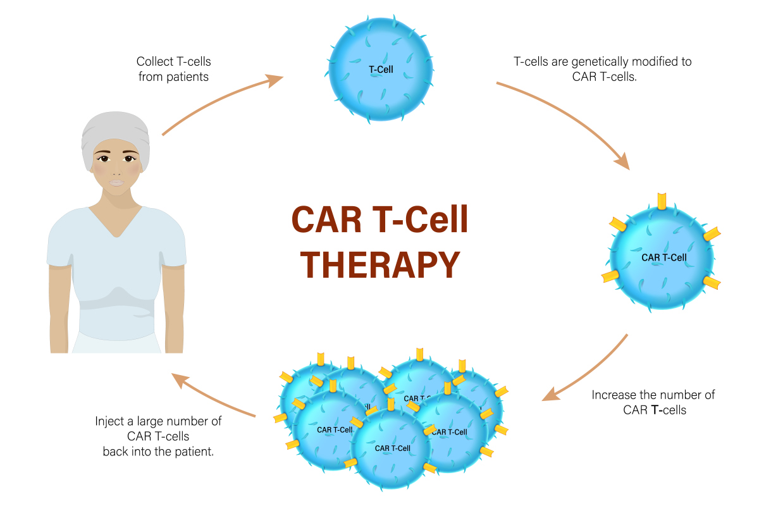

Your Task
The International Health Planning Commission (IHPC) has commissioned your team to develop one or more mathematical models to address the following problems. Your final report must include a one-page Executive Summary, presenting your key recommendations to the non-technical officials of IHPC.

Numerous autoimmune and inflammatory diseases could potentially benefit from Treg therapy. Construct a multi-dimensional evaluation model to determine which diseases should be prioritized as primary targets for Treg therapy R&D. Your model should consider factors including, but not limited to: global disease burden (e.g., incidence, mortality, disability rates), shortcomings of current treatments (e.g., efficacy, side effects, cost), and the potential clinical success rate of Treg therapy for each disease (based on animal studies or early clinical data). Using your model, prioritize at least three diseases (e.g., Type 1 Diabetes, Multiple Sclerosis, Systemic Lupus Erythematosus) and justify your ranking.

The IHPC plans to invest a total of $50 billion global R&D fund over the next ten years. Develop a dynamic resource allocation model to optimize the distribution of these funds across different R&D stages (e.g., basic research, preclinical research, Phase I/II/III clinical trials). Your model must balance short-term gains (e.g., rapidly advancing promising therapies) with long-term breakthroughs (e.g., solving fundamental scientific challenges), aiming to maximize the expected global health benefit. Use your model to simulate fund flow and R&D progress over the coming decade.

The efficacy of Treg therapies varies significantly among individuals. Build a predictive model to assess a specific patient's likelihood of responding to Treg therapy. The model should incorporate individual patient characteristics such as: age, genetic background (e.g., HLA genotype), baseline immune status (e.g., initial Treg cell count, inflammatory cytokine levels), and disease activity. Discuss how your model could assist clinicians in patient selection, thereby improving clinical trial success rates and reducing medical risks.

Advanced cell therapies are often prohibitively expensive, potentially exacerbating global health inequalities. Design a global framework for equitable pricing and distribution. Your framework should propose concrete policy recommendations, such as: tiered pricing strategies based on national ability-to-pay, establishing regional production centers to reduce costs and supply chain risks, and using profits from high-income countries to subsidize treatment costs in low-income countries. Apply your framework to a hypothetical scenario: once a Treg therapy for Type 1 Diabetes successfully reaches the market in 2030, how can its global accessibility be ensured?

The IHPC is concerned about the potential emergence of one or a few "technological monopolies" in the Treg therapy domain, which could drive up prices and stifle innovation. Conduct a scenario analysis, modeling how therapy price, accessibility, and subsequent R&D incentives might differ under two distinct market structures: one with a technological monopoly and one with robust competition. Based on all your models and analyses, write a strategic memorandum to the IHPC. Clearly outline the core strategies that should be adopted globally in the field of Treg therapies to maximize positive health impact and minimize inequality.

Your PDF solution of no more than 25 total pages should include:
• One-page Summary Sheet.
• Table of Contents.
• Your complete solution.
• References list.
• AI Use Report (If used does not count toward the 25-page limit.)

Note: There is no specific required minimum page length for a complete MCM submission. You may use up to 25 total pages for all your solution work and any additional information you want to include (for example: drawings, diagrams, calculations, tables). Partial solutions are accepted. We permit the careful use of AI such as ChatGPT, although it is not necessary to create a solution to this problem. If you choose to utilize a generative AI, you must follow the COMAP AI use policy. This will result in an additional AI use report that you must add to the end of your PDF solution file and does not count toward the 25 total page limit for your solution.

